Test Case: tc002_SPX_Dev5_Crear_Requisicion_Spot_Con_FAD_Tipo_Cobro_CC
Step 1 - Enter username and password and click to button Enter : Credentials Entered
Image file-name: QC_Testing-tc002_SPX_Dev5_Crear_Requisicion_Spot_Con_FAD_Tipo_Cobro_CC-1789483288418

Step 2 - Select to UEN and Access to Spot Buy Requisitions : UEN Correctly selected and Correct access
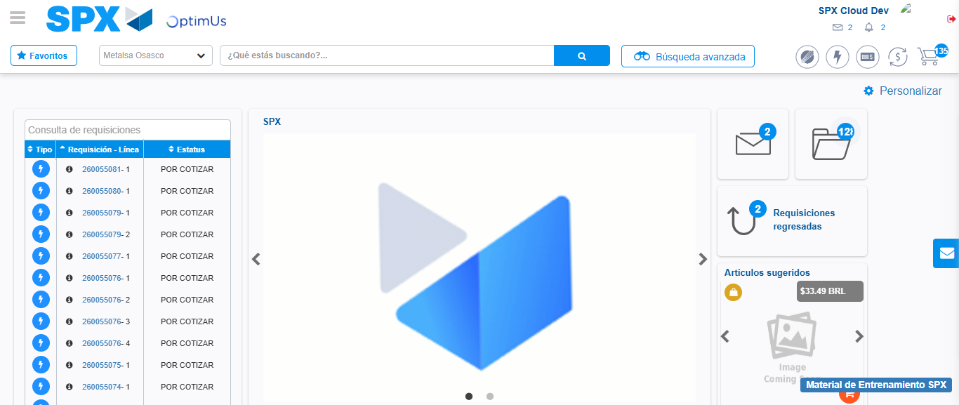Image file-name: QC_Testing-tc002_SPX_Dev5_Crear_Requisicion_Spot_Con_FAD_Tipo_Cobro_CC-1789483311262

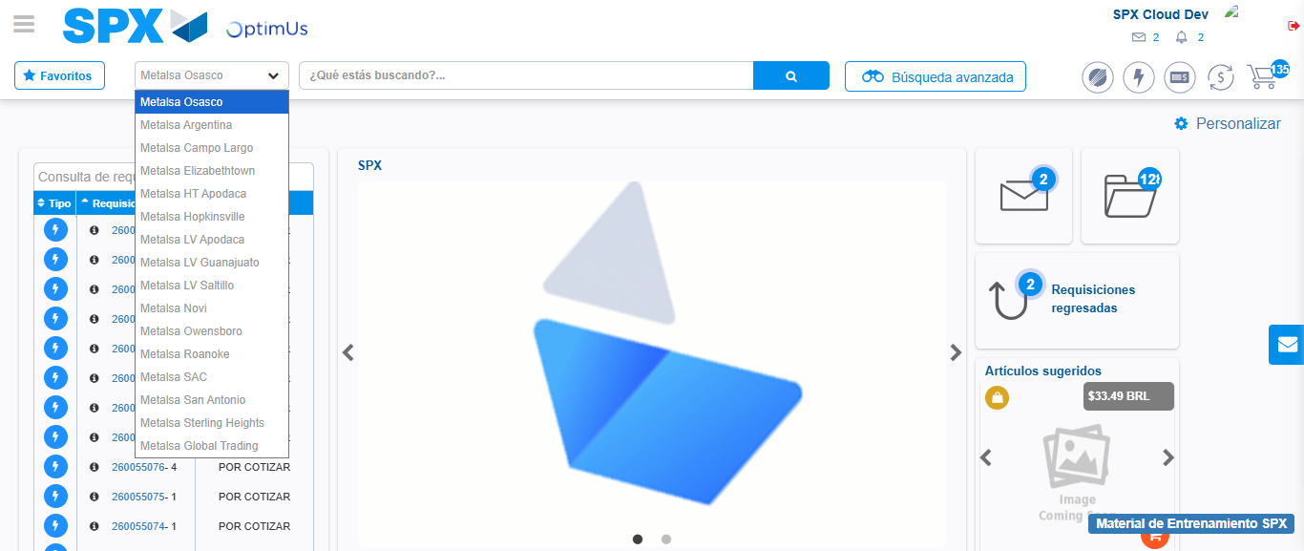Image file-name: QC_Testing-tc002_SPX_Dev5_Crear_Requisicion_Spot_Con_FAD_Tipo_Cobro_CC-1789483311795

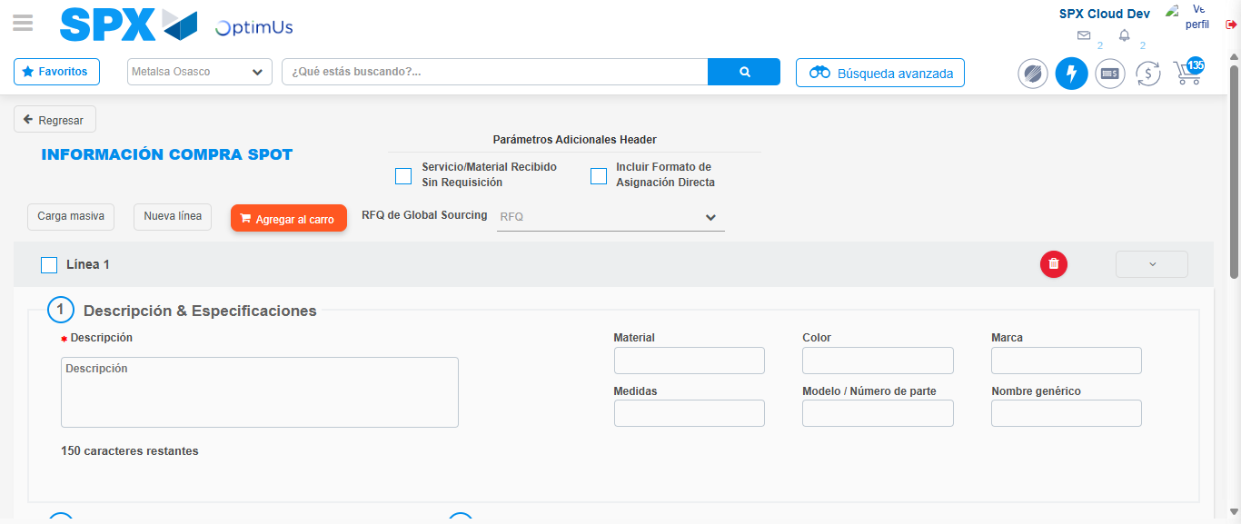Image file-name: QC_Testing-tc002_SPX_Dev5_Crear_Requisicion_Spot_Con_FAD_Tipo_Cobro_CC-1789483315908

Step 3 - Add FAD to Requisition: FAD Successfully Added
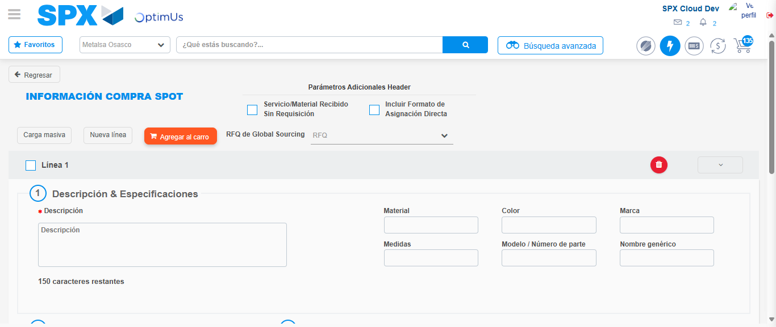Image file-name: QC_Testing-tc002_SPX_Dev5_Crear_Requisicion_Spot_Con_FAD_Tipo_Cobro_CC-1789483316255

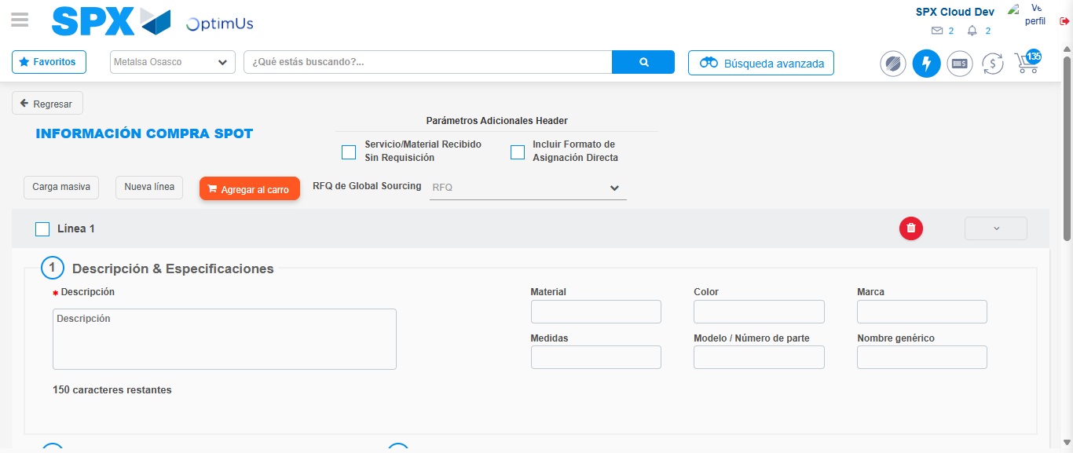Image file-name: QC_Testing-tc002_SPX_Dev5_Crear_Requisicion_Spot_Con_FAD_Tipo_Cobro_CC-1789483316490

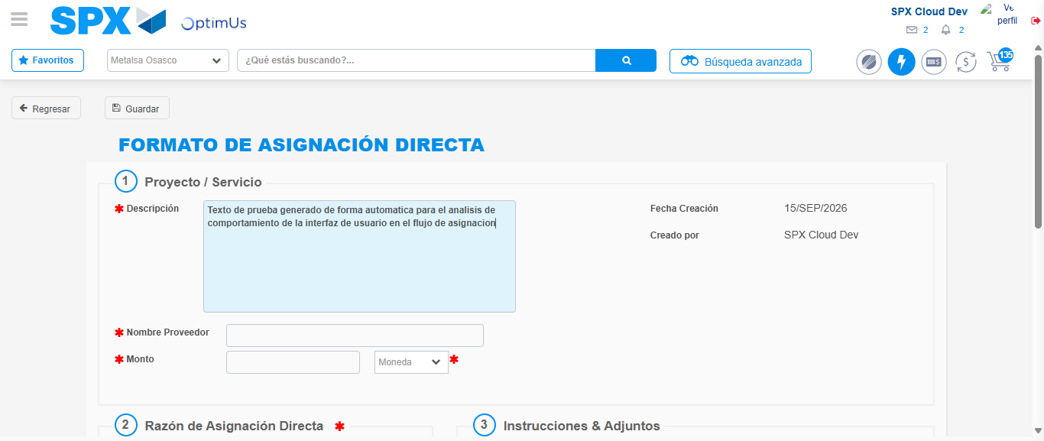Image file-name: QC_Testing-tc002_SPX_Dev5_Crear_Requisicion_Spot_Con_FAD_Tipo_Cobro_CC-1789483319236

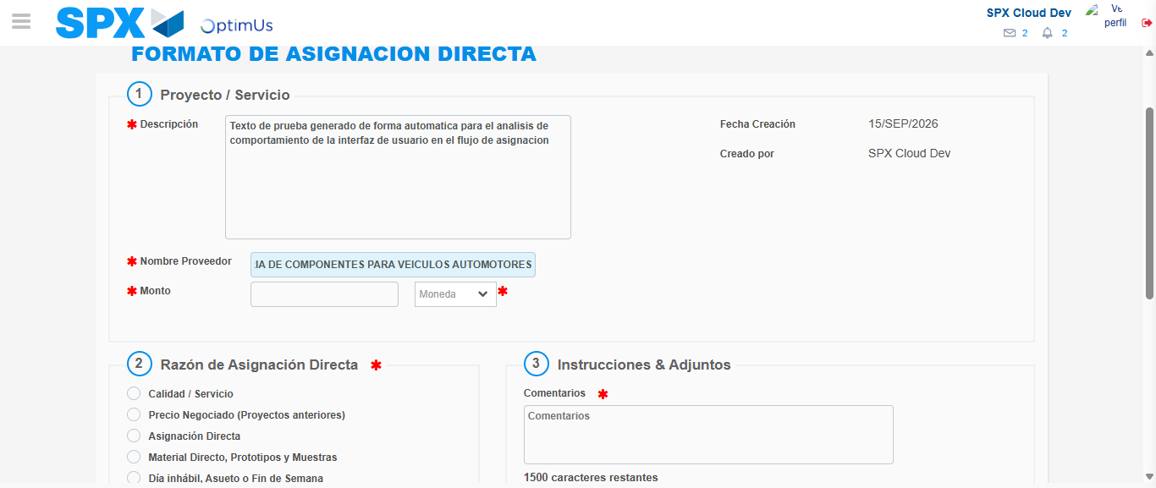Image file-name: QC_Testing-tc002_SPX_Dev5_Crear_Requisicion_Spot_Con_FAD_Tipo_Cobro_CC-1789483327728

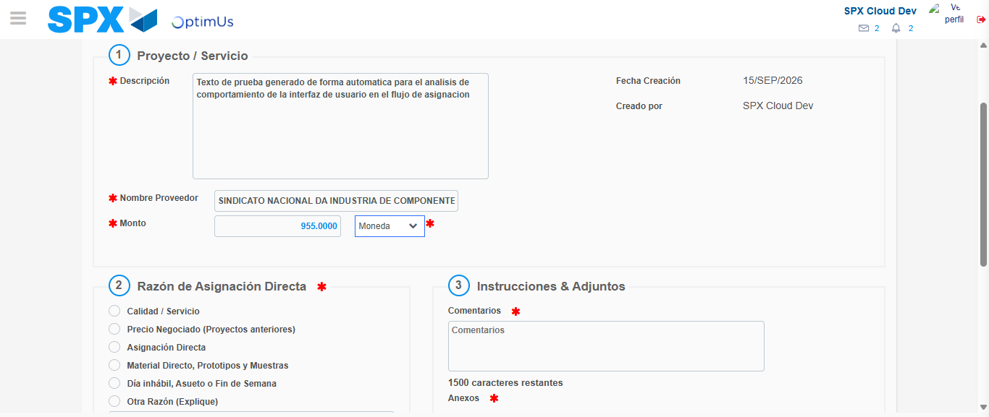Image file-name: QC_Testing-tc002_SPX_Dev5_Crear_Requisicion_Spot_Con_FAD_Tipo_Cobro_CC-1789483328096

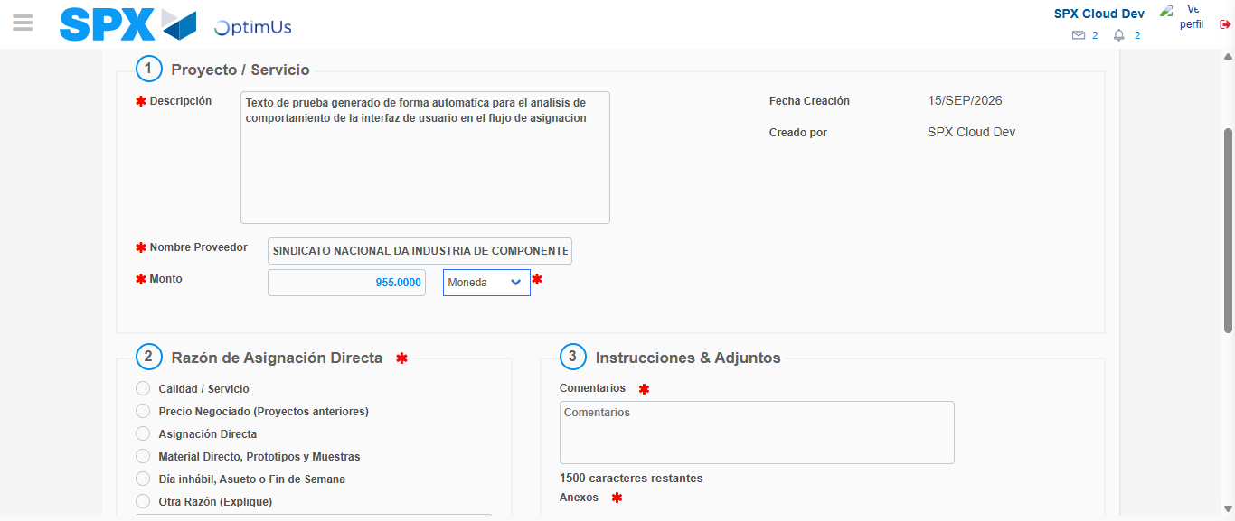Image file-name: QC_Testing-tc002_SPX_Dev5_Crear_Requisicion_Spot_Con_FAD_Tipo_Cobro_CC-1789483328312

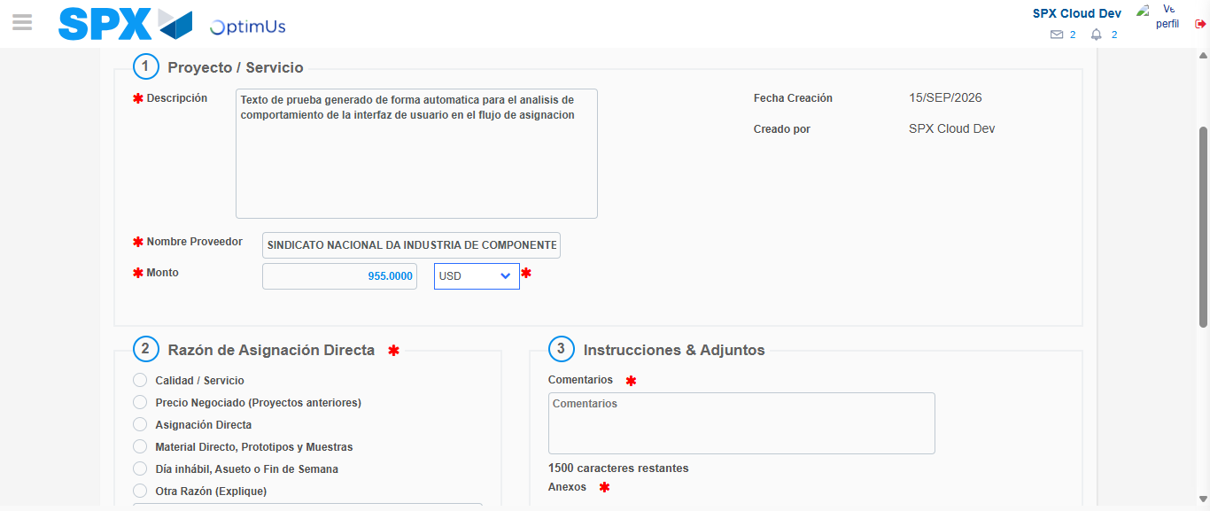Image file-name: QC_Testing-tc002_SPX_Dev5_Crear_Requisicion_Spot_Con_FAD_Tipo_Cobro_CC-1789483328664

Image file-name: QC_Testing-tc002_SPX_Dev5_Crear_Requisicion_Spot_Con_FAD_Tipo_Cobro_CC-1789483328854

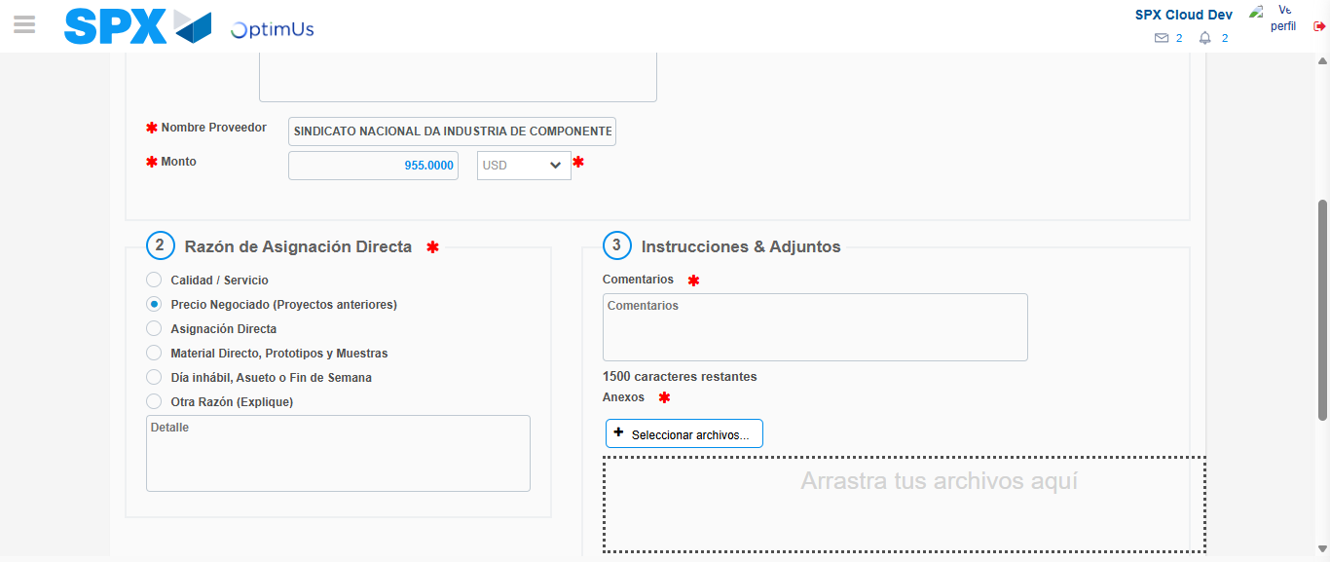Image file-name: QC_Testing-tc002_SPX_Dev5_Crear_Requisicion_Spot_Con_FAD_Tipo_Cobro_CC-1789483329627

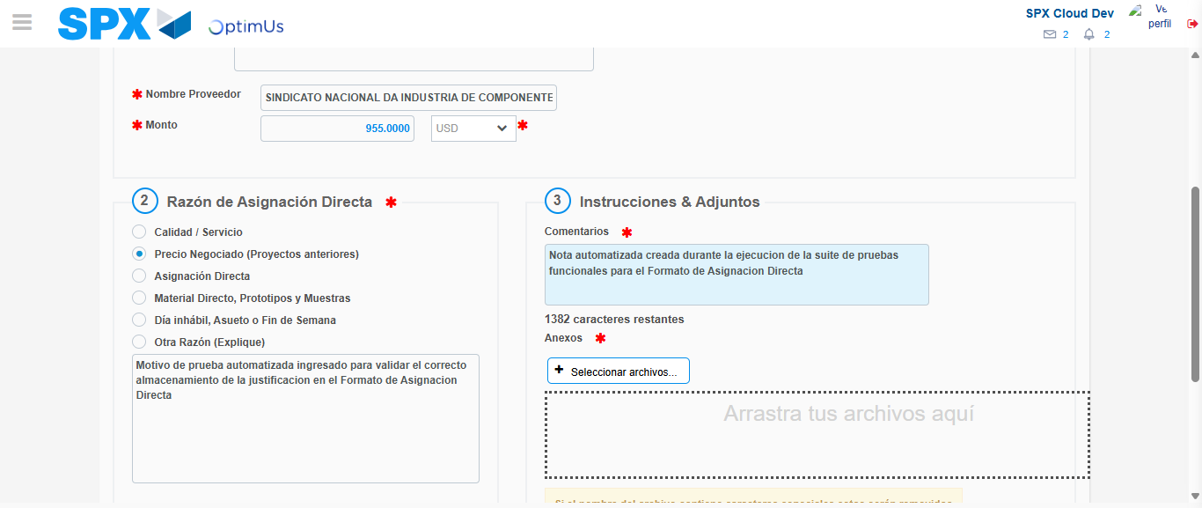Image file-name: QC_Testing-tc002_SPX_Dev5_Crear_Requisicion_Spot_Con_FAD_Tipo_Cobro_CC-1789483340603

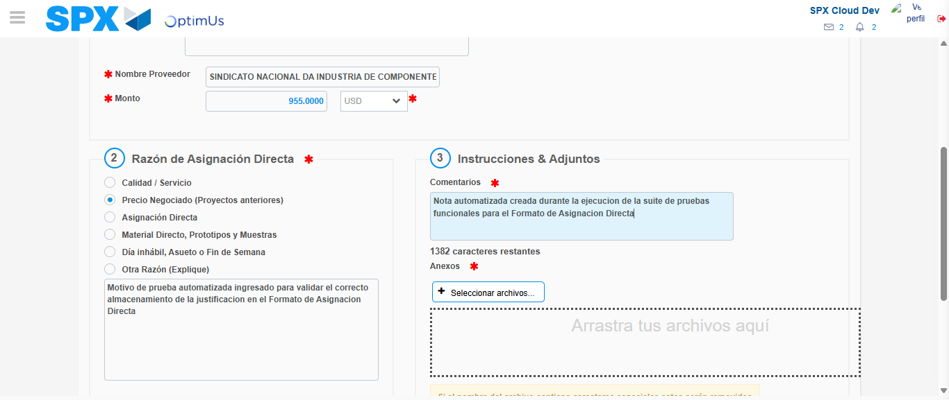Image file-name: QC_Testing-tc002_SPX_Dev5_Crear_Requisicion_Spot_Con_FAD_Tipo_Cobro_CC-1789483341218

Step 4 - Data Capture Spot Buy Requisition: Data captured correctly
Image file-name: QC_Testing-tc002_SPX_Dev5_Crear_Requisicion_Spot_Con_FAD_Tipo_Cobro_CC-1789483316255

Image file-name: QC_Testing-tc002_SPX_Dev5_Crear_Requisicion_Spot_Con_FAD_Tipo_Cobro_CC-1789483316490

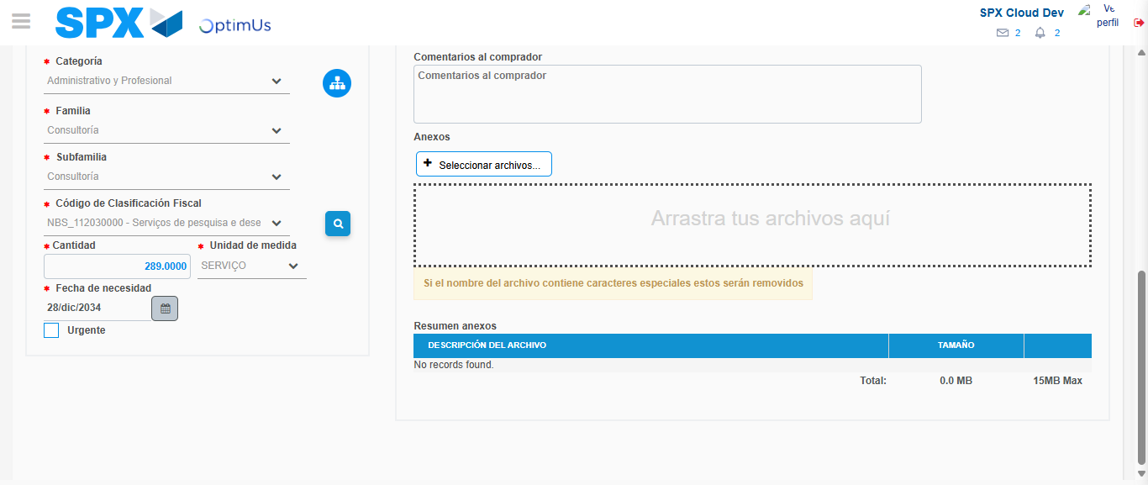Image file-name: QC_Testing-tc002_SPX_Dev5_Crear_Requisicion_Spot_Con_FAD_Tipo_Cobro_CC-1789483358348

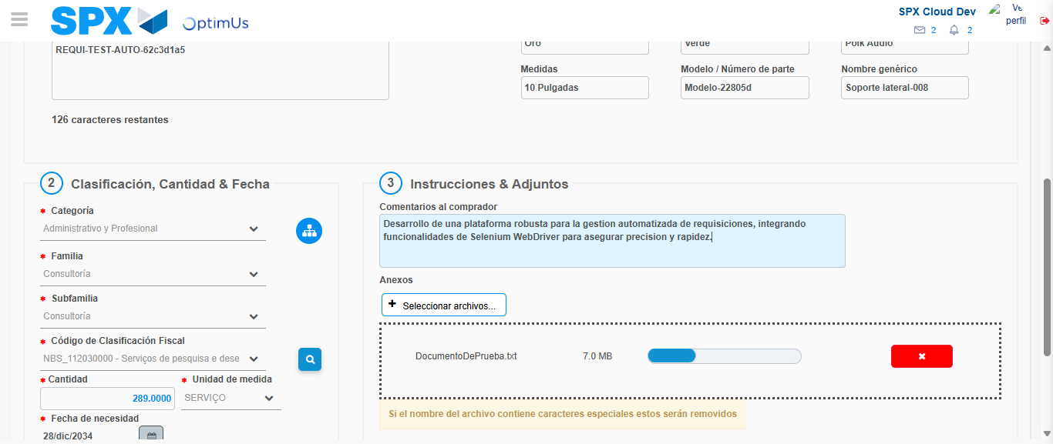Image file-name: QC_Testing-tc002_SPX_Dev5_Crear_Requisicion_Spot_Con_FAD_Tipo_Cobro_CC-1789483359088

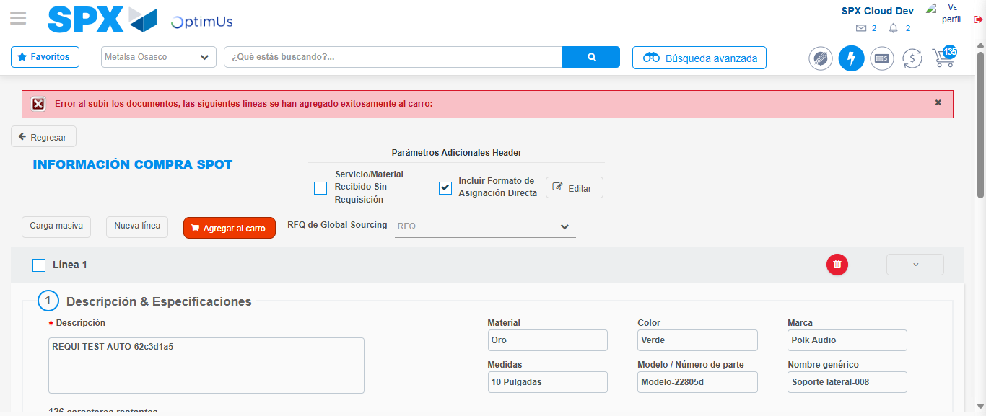Image file-name: QC_Testing-tc002_SPX_Dev5_Crear_Requisicion_Spot_Con_FAD_Tipo_Cobro_CC-1789483375150

Step 8 - Return to Main Page SPX : Return to Main Page SPX
Image file-name: QC_Testing-tc002_SPX_Dev5_Crear_Requisicion_Spot_Con_FAD_Tipo_Cobro_CC-1789483311262

Image file-name: QC_Testing-tc002_SPX_Dev5_Crear_Requisicion_Spot_Con_FAD_Tipo_Cobro_CC-1789483311795

Image file-name: QC_Testing-tc002_SPX_Dev5_Crear_Requisicion_Spot_Con_FAD_Tipo_Cobro_CC-1789483315908

Image file-name: QC_Testing-tc002_SPX_Dev5_Crear_Requisicion_Spot_Con_FAD_Tipo_Cobro_CC-1789483377679

Image file-name: QC_Testing-tc002_SPX_Dev5_Crear_Requisicion_Spot_Con_FAD_Tipo_Cobro_CC-1789483377894

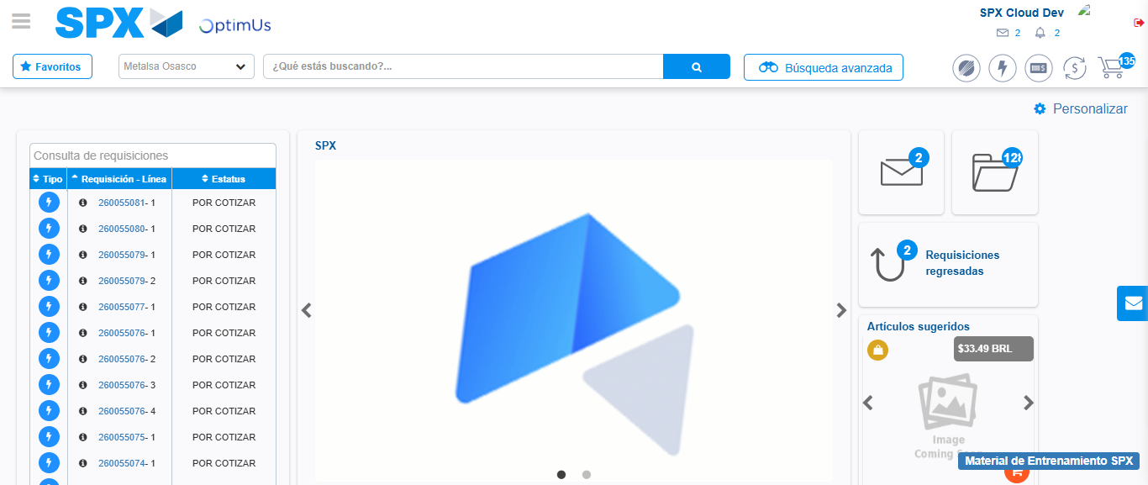Image file-name: QC_Testing-tc002_SPX_Dev5_Crear_Requisicion_Spot_Con_FAD_Tipo_Cobro_CC-1789483399192

Step 9 - Log Out : Log Out SPX
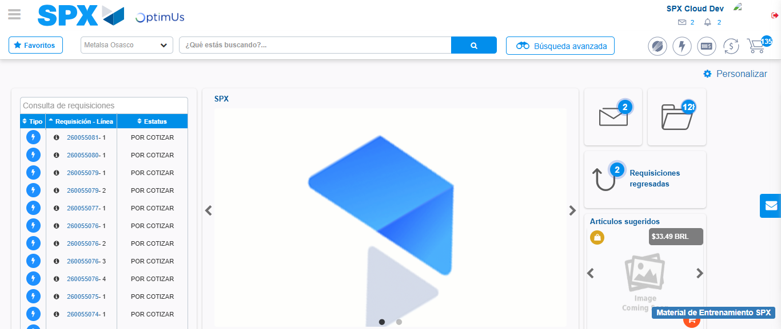Image file-name: QC_Testing-tc002_SPX_Dev5_Crear_Requisicion_Spot_Con_FAD_Tipo_Cobro_CC-1789483399471

